

**North South University**

**Department of Electrical & Computer Engineering**

**LAB REPORT**

**Analog Electronics Lab**

**EEE111L**

**Experiment Number: 7**

**Experiment Name:** The BJT Biasing Circuits

**Experiment Date:** 6/12/2021

**Report Submission Date:** 13/12/2021

**Section:** 7 **Group No:** 2

**Students Name & ID:**

1. Md Kawser Islam – 1912296642 **(Report Writer)**
2. Yusuf Abdullah Tonmoy – 1620456042
3. Fardin Bin Islam – 1721588642
4. Tusher Saha Nirjhor – 1921793642
5. Md. Rifat Ahmed – 193172504

|  |  |  |
| --- | --- | --- |
| **Remarks:** | Score |  |
|  |  |
|  |  |  |
|  |  |  |

**Objectives:**

• Our objective in this experiment is to study the switching characteristics of MOSFET.

**Theory:**

**MOSFET:**

A MOSFET is mainly a three-terminal device that has: source (S), gate (G), drain (D) but there’s also a fourth terminal bulk or body (B). The body of the MOSFET is usually connected to the source terminal, forming a three-terminal device such as a field-effect transistor. MOSFET is a type of transistor that is used in both circuits (analog and digital)

**Working Principle of MOSFET:**

The ability to control the voltage and current flow between the source and drain terminals is the primary principle of the MOSFET device. The device's operation is based on the MOS capacitor, which functions almost like a switch. The essential component of a MOSFET is the MOS capacitor. By applying positive or negative gate voltages to the semiconductor surface beneath the oxide layer, which is positioned between the source and drain terminal, the semiconductor surface can be inverted from p-type to n-type. When the positive gate voltage is applied with a repulsive force, the holes beneath the oxide layer are pushed downward with the substrate. The bonded negative charges linked with the acceptor atoms populate the depletion area. A channel is formed when electrons are accessed. The positive voltage also draws electrons into the channel from the n+ source and drain regions. When a voltage is supplied between the drain and the source, the current between the source and the drain flows freely, and the gate voltage regulates the electrons in the channel. If we apply a negative voltage instead of a positive voltage, a hole channel will form beneath the oxide layer.

**MOSFET Regions of Operation:**

To the most general scenario, the operation of this device happens mainly in three regions and those are as follows:

**Cut-off Region:**

It is the region when the gadget is turned off and no current flows through it. The gadget serves as a simple switch in this case, and it is used when electrical switches are required.

**Saturation Region:**

In this region, the devices will have their drain to source current value as constant without considering the enhancement in the voltage across the drain to source. This happens only once when the voltage across the drain to source terminal increases more than the pinch-off voltage value. In this scenario, the device functions as a closed switch where a saturated level of current across the drain to source terminals flows. Due to this, the saturation region is selected when the devices are supposed to perform switching.

**Linear/Ohmic Region:**

It's the point at which the current across the drain to source terminal increases when the voltage across the drain to source path rises. When MOSFET devices operate in this linear zone, they function as amplifiers.

Let's have a look at MOSFET switching characteristics.

A semiconductor, such as a MOSFET or Bipolar Junction Transistor, functions as a switch in two states: ON and OFF. Let's take a look at the ideal and practical properties of the MOSFET device to understand this functioning.

**Ideal Switch Characteristics:**

When a MOSFET is supposed to function as an ideal switch, it should hold the below properties and those are

• In the ON condition, there has to be the current limitation that it carries.

• In the OFF condition, blocking voltage levels should not hold any kind of limitations. • When the device functions in ON state, the voltage drop value should be null.

• The resistance in OFF state should be infinite.

• There should be no restrictions on the speed of operation.

**Practical Switch Characteristics:**

As the world is not just stuck to ideal applications, the functioning of MOSFET is even applicable for practical purposes. In the practical scenario, the device should hold the below properties

• In the ON condition, the power managing abilities should be limited which means that the flow of conduction current has to be restricted.

• In the OFF state, blocking voltage levels should not be limited.

• Turning ON and OFF for finite times restricts the limiting speed of the device and even limits the functional frequency.

• In the ON condition of the MOSFET device, there will be minimal resistance values where this results in the voltage drop in forwarding bias. Also, there exists finite OFF state resistance that delivers reverse leakage current.

• When the device is performing in practical characteristics, it loses power at ON and OFF conditions. This happens even in the transition states too.

**Equipment List:**

• MOSFET (IRF540) – 1 piece

• Resistor (1kΩ)

• Trainer Board

• DC Power Supply

• Digital Multimeter

• Cords and wires

**Circuit Diagram:**

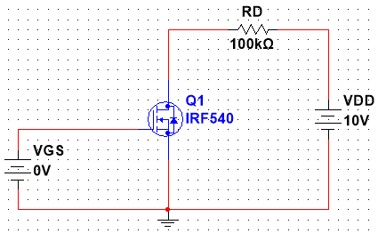

Figure 1: MOSFET Circuit with VDD = 10V

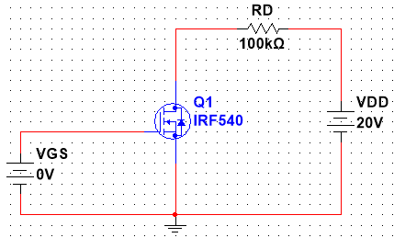

Figure 2: MOSFET Circuit with VDD = 20V

**Data & Table:**

**Table 1:** Device Parameter Sweep Table for VDD = 10V

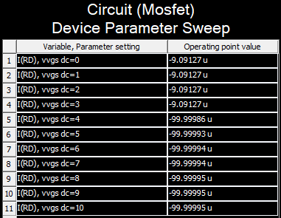

**Table 2:** Device Parameter Sweep for VDD = 20V

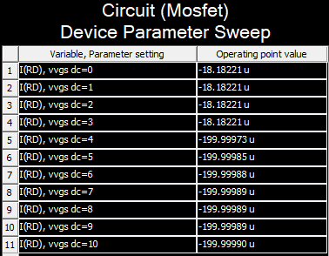

**Result Analysis & Discussion:**

In this experiment we learnt about the MOSFET and its switching characteristics. We also learnt that MOSFETs are voltage controlled high input impedance device and there are two types of MOSFETs – enhancement type and depletion type and these could also be of two types p-type and n-type, so overall there are four types of MOSFETs. And then we learnt that MOSFETs generally have three terminals drain, source and gate but there could be a fourth terminal called bulk or body terminal. A MOSFET is operating in the Ohmic or Linear region when its current IDD increases with the value of VDD and in this region they work like an amplifier. Then if a MOSFET is in cutoff region its VGS is very low and so there’s no current flow so the MOSFET behaves like an open switch. And then when the MOSFET is in saturation region where it has a constant IDD even if there’s an increase in the VDD and it happens when the VDS exceeds the pinch-off voltages value. In this this region the device acts like a closed switch where a saturated value of IDD flows through the device and so this operating region is required for a MOSFET to work as a switch. So, with the cutoff region and the saturation region we can see the switching characteristics of a MOSFET and we can see how results vary with the increase of VDD if we look at Table 1 and 2.

So using Multisim we did the simulation perfectly so we think everything went perfectly during this lab experiment and there was no lacking.

**Contributions:**

|  |  |
| --- | --- |
| **Name & ID** | **Contribution** |
| Md Kawser Islam – 1912296642 (**Report Writer)** | Data & Table |
| Fardin Bin Islam – 1721588642 | Theory |
| Yusuf Abdullah Tonmoy – 1620456042 | Circuit Diagram |
| Tusher Saha Nirjhor - 1921793642 | Equipment List |
| Md. Rifat Ahmed – 1931725042 | Result Analysis & Discussion, Attachment |

**Attachment:**

**Task 01:**

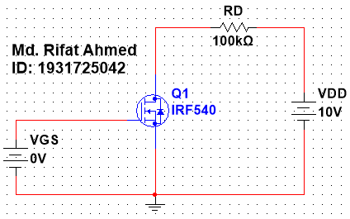

Figure 1: MOSFET Circuit with VDD = 10V

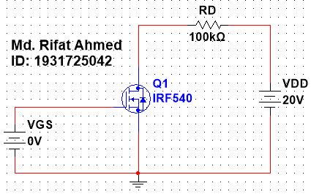

Figure 2: MOSFET Circuit with VDD = 20V

**Task 02:**



Figure 3: “Device Parameter Sweep” Table for VDD = 10V



Figure 4: “Device Parameter Sweep” Table for VDD = 20V

**Task 03:**

In this experiment we’ll looking at 2 MOSFET circuits with different VDD and see the difference in their switching characteristics. After building the circuit we took the values of I(RD) using Parameter Sweep. Then we changed the value of VDD to 20V and again took the values of I(RD). Looking at the 1st table we can see that at the beginning until 3V the value of I(RD) is small and constant for VDD = 10V. But from 4V the value of current increases around 10 times and is almost constant until it reaches 10V. Then we see the similar thing happening for the circuit with VDD = 20V from the 2nd table the value of I(RD) is constant at the beginning then jumps to a higher value and again runs almost at a constant current. But one thing that needs to be remembered is that the values are positive even though there’s a negative sign in the figures.

**References:**

• Agarwal, T. (2020, September 2). What is the MOSFET: Basics, Working Principle and Applications. ElProCus - Electronic Projects for Engineering Students

<https://www.elprocus.com/mosfet-as-a-switch-circuit-diagram-free-circuits/>

• S. (2021, July 22). What Is a MOSFET? | Basics for Beginners. Electronics For You

[[https://www.electronicsforu.com/technology-trends/learn-electronics/mosfet-basics-working-applications](https://www.electronicsforu.com/technology-trends/learn-electronics/mosfet-basics-working-applications" \o "https://www.electronicsforu.com/technology-trends/learn-electronics/mosfet-basics-working-applications)](https://www.electronicsforu.com/technology-trends/learn-electronics/mosfet-basics-working-applications)

• Wikipedia contributors. (2021b, August 3). MOSFET. Wikipedia

<https://en.wikipedia.org/wiki/MOSFET>